# **This document contains the necessary instructions for: Upgrading to CubeVue 4.2.0.1 in section A and Fresh Installing CubeVue 4.2.0.1 in section B.**

# **Instructions to Upgrade**

# **CubeVue v3.7.0.3/v3.9.0.996 Beta/v3.9.1.991 Beta/v3.9.1.995 Beta**

# **to**

# **CubeVue v4.2.0.1**

**Notes: If the customer is using *Patient View*, then this upgrade should not be performed because *Patient View* is not supported in v 4.2.0.1. If the customer still wishes to use *Patient View* then their preferred version to use is v3.7.0.3.**

**Prior to CubeVue 4.2.0.1:**

* **3.9.0.996 was preferred for applications involving LineUP and pedCAT MAR datasets.**
* **3.9.1.991 was preferred for applications involving HiRise datasets.**
* **3.9.1.995 was preferred for StandingCT applications.**

Steps to upgrade:

1. Run the existing version of CubeVue on the PC.
2. Archive the following information (these values may reset following the upgrade):
   1. From the *Network* tab of CubeVue *Settings*, note down the *Server* fields (*see screenshot below)*, the *Network Cache Size*, and the *Connect to image server at start up* checkbox setting.

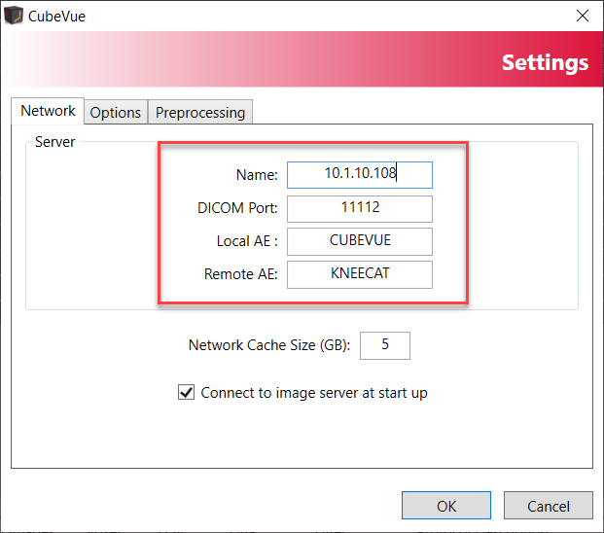

* 1. From the *Options* and *Preprocessing* tabs, note down all the current values/settings.

1. Create a backup of the following and save it to the upgrade PC:
   1. The *InstaXScripts* folder:

*C:\Program Files\CurveBeam LLC\CubeVue\client64\InstaXScripts*

Save the folder to the local PC (where the upgrade is being performed) and rename it as “InstaXScripts.backup”.

* 1. The user settings folder (named after the current CubeVue version):

*C:\Users\****UserName****\AppData\Local\CurveBeam_LLC\CubeVue.exe_StrongName_lvotad5z0ai5mxhysh0abt3nyvfxjhd3* ***3.7.0.3***

*Note:* The **UserName** in the above path is dependent upon the username of the PC.

*Save the folder to the local PC (where the upgrade is being performed).*

1. Close all running instances of CubeVue.
2. Run the CubeVue 4.2.0.1 installer (right-click on CVIM.exe and select ‘Run as Administrator’) and follow the on-screen instructions to complete the installation.

*Note:* The default language is selected during installation. The available language options are: English, French, German, and Italian.

1. Once CubeVue 4.2.0.1 is installed open the *Settings* dialog (CubeVue will automatically run after the installation is complete).
2. Enter the previously archived values (Step 2) into the *Settings* tabs and click the “OK” button to apply the previous settings from CubeVue v3.7.0.3/v3.9.0.996 Beta/v3.9.1.991 Beta/v3.9.1.995 Beta.
3. Restart CubeVue and make sure the values entered are retained in the *Settings* dialog.

*If the values are NOT retained: 1) Close CubeVue. 2) Restart the computer. 3) Repeat steps 7 and 8.*

1. Once the *Network, Options,* and *Preprocessing* values are retained in the *Settings* dialog, close CubeVue.

**Please Note: The next 3 steps in these upgrade instructions are machine-specific.**

1. If upgrading for **HiRise only**, the default MPR image filter should be set to *Normal*, on the *Settings*|*Other* tab as shown in the screenshot below:

1. If upgrading the CubeVue for **pedCAT only**:
   1. Close CubeVue if already running.
   2. Navigate to the following location: C:\Program Files\CurveBeam LLC\CubeVue\client64
   3. Make sure *File name extensions* and *Hidden items* checkboxes are checked in Windows Explorer as shown in the screenshot below:

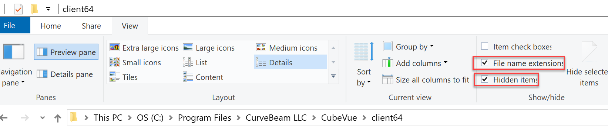

* 1. Create a new file in this location (could be a blank notepad file) and rename this file to *NoColDamp.cfg* as shown in screenshot below:

1. This step is applicable for **InReach sites only** (skip this step if CubeVue is used for datasets from any other scanning device):
   1. Make sure CubeVue application is closed.
   2. Open the following location on the PC running CubeVue: C:\Program Files\CurveBeam LLC\CubeVue\client64\SimXScripts\Knee
   3. Delete the 3 files in the Knee folder. The name of the files are: ‘AutoBuildScripts.xml, AutoBuildSets1.xml & AutoBuildSets2.xml’
   4. Unzip the attached zip folder, “Knee SimX for InReach ONLY.zip”.
   5. Obtain the files ‘AutoBuildScripts.xml, AutoBuildSets1.xml & AutoBuildSets2.xml’ from the unzipped folder.
   6. Place the xml files into the directory location in 12b.
2. **This step is for informational purposes and** **should only be executed if the upgrade is performed at a site where customized SimX (previously known as Insta-X) images are being used:**
   1. Once the new version of CubeVue is installed, all the new scripts are present in a new folder (C:\Program Files\CurveBeam LLC\CubeVue\client64\SimXScripts)
   2. All the old images are still preserved at the old location (C:\Program Files\CurveBeam LLC\CubeVue\client64\InstaXScripts)
   3. Loading any dataset shall reference the new SimXScripts folder i.e., SimX images will be generated from the scripts present in SimXScripts folder. The SimXScripts folder supports all the anatomies which were not supported in the past versions of CubeVue (e.g. Hip, Pelvis, LowerLimb, LowerLeg scans).
   4. **If a customer has customized scripts**, those scripts can be placed in the SimXScripts folder using the relevant InstaXScripts folder as reference; here are the steps which can be used (Foot anatomy is taken as a sample to explain the steps):
      1. Please note that the *pedCATFoot* folder in InstaXScripts is now named as *Foot* folder in SimXScripts folder). All other folders still have same names.
      2. Navigate to C:\Program Files\CurveBeam LLC\CubeVue\client64\SimXScripts\Foot
      3. Three xml files are present; AutoBuildScripts.xml, AutoBuildSet1.xml & AutoBuildSet2.xml.
      4. Open the AutoBuildScripts.xml and note down the *FileVersion* number; this will be needed in one of the steps below. Here is a sample screenshot of how the *FileVersion* looks like:

* + 1. Close the xml file.
    2. ‘Move’ the 3 xml files to any backup location on the computer.
    3. Open the following location: C:\Program Files\CurveBeam LLC\CubeVue\client64\InstaXScripts\pedCATFoot
    4. Copy the AutoBuildScripts.xml, AutoBuildSet1.xml & AutoBuildSet2.xml files from pedCATFoot folder and place these files into *C:\Program Files\CurveBeam LLC\CubeVue\client64\SimXScripts\Foot*
    5. Open the AutoBuildScrips.xml file in the new location (i.e., SimXScripts\Foot) and update the *FileVersion* number as noted in step iv above.
    6. Append letter c after the version number. Here is a sample screenshot of how it should look like:

* + 1. Save and close the xml file.

This concludes the upgrade of CubeVue v3.7.0.3/v3.9.0.996 Beta/v3.9.1.991 Beta/v3.9.1.995 Beta to v4.2.0.1

# **Fresh Installing CubeVue 4.2.0.1**

1. Locate the CVIM.exe in the installer package.
2. Right click on CVIM.exe and select ‘Run as administrator’.

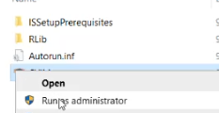

1. A *User Account Control* confirmation message may be displayed, select ‘Yes’.
2. CubeVue Install Manager dialog box is displayed, click on *Install CubeVue v4.2.0.1* button.
3. Select the desired Setup language; available options are English, French, German and Italian. The text on the dialog boxes during installation will be displayed in the selected language.
4. Accept the *License Agreement* and click on *Next* button.
5. On the *Select Additional Tasks* dialog box, click on *Next* button leaving the default value as such.
6. Click on *Install* button on the *Ready to Install* dialog box.
7. Click on *Finish* button on the displayed dialog to complete the installation.
8. CubeVue will automatically run after the installation is complete.
9. Please note that the next 3 steps below are machine specific and to be executed if CubeVue is installed on the specific machine mentioned in each step.
10. If installing the CubeVue for **HiRise**, make sure CubeVue is still running and set the default MPR image filter to Normal in CubeVue Settings|Other, as shown in the screenshot below:

1. If installing the CubeVue for **pedCAT**:
   1. Close CubeVue if already running.
   2. Navigate to the following location: C:\Program Files\CurveBeam LLC\CubeVue\client64
   3. Make sure *File name extensions* and *Hidden items* checkboxes are checked in Windows explorer as shown in screenshot below:



* 1. Create a new file in this location (could be a blank notepad file), rename this file to *NoColDamp.cfg* as shown in screenshot below:

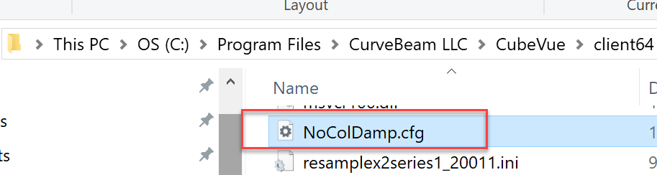

1. This step is applicable for **InReach sites only** (skip this step if CubeVue is used for datasets from any other scanning device):
   1. Make sure CubeVue application is closed.
   2. Open the following location on the PC running CubeVue: C:\Program Files\CurveBeam LLC\CubeVue\client64\SimXScripts\Knee
   3. Delete the 3 files in the Knee folder. The name of the files are: ‘AutoBuildScripts.xml, AutoBuildSets1.xml & AutoBuildSets2.xml’
   4. Unzip the attached zip folder, “Knee SimX for InReach ONLY.zip”.
   5. Obtain the files ‘AutoBuildScripts.xml, AutoBuildSets1.xml & AutoBuildSets2.xml’ from the unzipped folder.
   6. Place the xml files into the directory location mentioned in step 14b.

This concludes the installation of CubeVue 4.2.0.1 on a fresh computer where CubeVue has not been installed before.

**Revision History:**

|  |  |  |  |
| --- | --- | --- | --- |
| **Revision History** | | | |
| **Rev** | **Revision Date** | **Description of Change** | **Revised by** |
| A | 12/17/2019 | Initial release | Samantha Irving |
| B | 10/27/2022 | Updating the upgrade instruction from 3.7.0.3 to 3.9.0.996 because v3.9.0.6 has expired making the existing upgrade instructions unusable. Also adding the instructions to upgrade from 3.7.0.3 to v 3.9.1.991 or 3.9.1.995. | Samantha Irving |
| C | 09/20/2024 | Updated the instructions for the upgrade from CubeVue 3.7.0.3 or 3.9.0.996 or 3.9.1.991 or 3.9.1.995 to CubeVue 4.2.0.1  Updated the name of the document to convey the upgrade info.  Added the pedCAT specific steps which involve placing NoColDamp.cfg file in C:\Program Files\CurveBeam LLC\CubeVue\client64 folder. | Ravinder Dangi |